Henry Whipple
Primary School

EYFS



1 | Intent / Implementation / Impact  Subject area statement
2 | Curriculum subject on a page overview

1 | Intent / Implementation / Impact  Subject area statement

INTENT (vision)
At Henry Whipple we ………
- Provide a learning environment where quality interactions with children are the focus and communication and language skills are promoted.

- provide our children with a curriculum that is designed to be flexible, engaging and exciting so that their unique needs, passions and interests are embraced in the context of a small school in an area of deprivation

- know that every child is an exceptional individual and we celebrate and respect differences within our diverse school community

- Commit to the teaching of basic skills, knowledge and values that equips our children for their future successes stable resources which enrich the quality of provision in a holistic space

- inspire our children to become accomplished, happy individuals, ready to reach their full potential in an ever-changing world

- recognise that children’s prior learning and experiences are influenced by their home and community and plan a curriculum that responds to it

- provide first hand learning experiences and address language deficits

- allow the children to develop interpersonal skills and build resilience through our ‘Believe, Belong, Achieve’ ethos to become critical and creative thinkers

- provide children with opportunities to independent and resilient learners

- prepare children and provide effective transition to year 1

IMPLEMENTATION: (how)
Our Early Years Foundation Stage vision is translated into practice by…
- planning following the Early Years Statutory Framework
- providing a curriculum that is child-centered and engages the children, whilst teaching essential knowledge and skills.
- encouraging active learning to ensure the children are motivated and interested.
- ensuring pupils learn through a balance of child-initiated and adult-directed activities.
- ensuring all areas of the EYFS curriculum are followed and planned for to ensure there is a broad, balanced and progressive learning environment and curriculum.
- offering learning experiences for the seven areas of the EYFS curriculum:

Communication and Language
Personal, Social & Emotional Development
Physical Development
Literacy
Mathematics
Understanding the World
Expressive Arts & Design

- staff training and engagement in moderation
- regularly assessing children, using ‘Development Matters’, used meaningfully to observe children and plot their progress as part of everyday practice using Tapestry.
- Regular team discussions, to ensure a broad view of children’s development.
- ensuring activities support the Characteristics of Effective Learning:
- investing in the wider curriculum by learning away, inviting external visitors
- Following an enhanced provision approach, allowing children to become familiar with and build upon learning of core resources, which are not changed. Enhancements added half termly extend learning further and link to learning themes and reading.
- Planning and modelling the use of high quality indoor continuous provision, that promotes development in all areas of the curriculum.
- Planning and modelling the use of high quality outdoor continuous provision, that promotes development in all areas of the curriculum.
- cultural capital development to enhance curriculum implementation
- ensuring that staff’s priority is quality interactions with children, that promote high quality communication and language skills.
- Allowing children to be independent in provision, accessing the tools and equipment necessary for their unique learning.
- Providing a key focus on reading, with each year group have 2 class readers per half term and providing provision that focuses on these books and the vocabulary within them.
- Planning focused interactions for teaching staff, following weekly review meetings to ensure that all children have the opportunity to meet their next steps.
- Planning and conducting effective transition - ensuring a smooth transition between Foundation 1 and 2 and EYFS and Year 1
- measuring the percentage of pupils meeting the age related expectations throughout the academic year.

IMPACT
At Henry Whipple Primary we endeavor to ensure that all children make progress from their varied starting points by …..

- striving for all children to reach a Good Level of Development within Early Learning Goals at the end of Foundation 2
2016/17 | 2017/18 | 2018/19 | 2019/20  Teacher Assess | 2020/21  Teacher Assess | 2021/2022
69% GLD | 65.5% GLD | 60% GLD | 61% forecast | 47% | 64.7%
- Staff have a high level of knowledge around the learning and next steps for each child, meaning their provision and interactions support their development specifically and effectively.
- Ensuring progress is at least good for all children, including vulnerable groups such as those with SEND, EAL, disadvantaged & summer born children. Baseline on entry across all areas of curriculum (ELG) and engagement with PPM’s informs shaping of plans and next steps through formal assessment every half term
- Pupils are Key Stage 1 ready and have our school values embedded by the time they leave Foundation 2 preparing them for their future.
- providing a range of information including specific data on SEND, PP, EAL
- Parents understand expectations and are aware of progress following expectations and pupil progress meetings
- Adapting curriculum and provision where necessary to meet the needs and interests of our children, ensuring they make maximum progress in each area.
- Children use new vocabulary independently in provision.
- Children are resilient learners, that can use provision and resources independently.
- Children in F1 and F2 make strong progress from their starting points, which are often below the expected for their age.

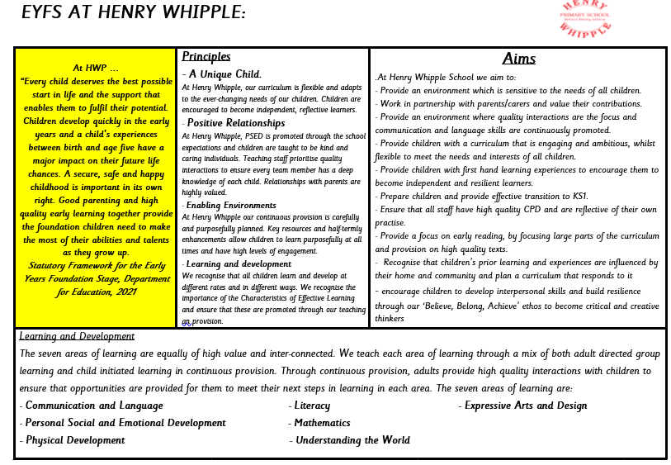

2 | Curriculum on a page overview

