Financial Benchmarking Report

February 2021



School Name: Henry Whipple Primary School

Supported by Schools Finance Support

Introduction
We have conducted a benchmarking exercise to compare Henry Whipple Primary School with 14 statistically comparable national schools to understand whether the school is demonstrating value for money in public spending. We have used 2019-20 financial data and the benchmarking tool on the schools financial benchmarking website to produce this benchmarking report as this is the latest information available.
Context
Henry Whipple Primary School was last inspected in June 2019 and rated as Good. The school is an average-sized primary school, the proportion of pupil from minority ethnic groups and pupils speaking English as an additional language is above average. The proportion of pupils supported by pupil premium is also higher than average.
Interpreting the data
You should take care when interpreting the data. It shows the position of a school relative to others, it doesn’t explain why this is. There may be good reasons for a school to have high or low figures. What’s important is that those involved in budget setting review the differences, and consider the reasons for them.
Staff costs

As staffing typically represents between 75% and 80% of mainstream schools’ expenditure, it’s important that schools review their staff structures regularly as part of their annual school improvement, curriculum and financial planning.

Premises costs
Next to staffing costs, premises costs can be one of the most expensive groups in the costing structure. This cost grouping includes premises staff, cleaning, caretaking, maintenance and improvement.
It is useful to look at the premises total expenditure as a percentage of total cost in the first instance and consider whether this is significantly higher or lower than others. This can sometimes be explained by the amount of income generated through the hire of the school’s facilities.
Some components in the premises costs block need to be looked at together. For example, if you have directly employed premises staff members, they often undertake basic maintenance and improvement tasks and this usually brings economies to schools. When comparing maintenance and improvement costs with other schools, it is also wise to look at premises staff costs at the same time.

Schools used in benchmarking comparison

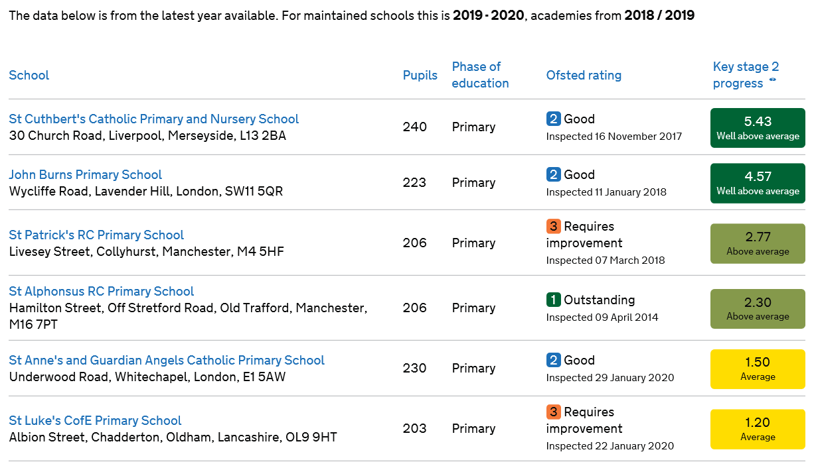
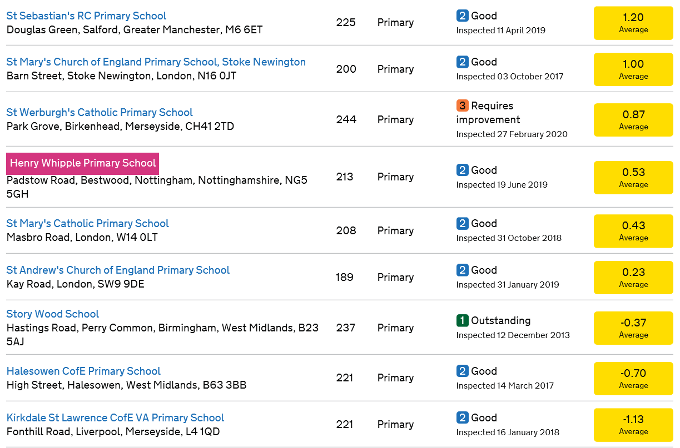

Senior Leadership (Full Time Equivalent)
This is the full-time equivalent of senior leadership roles.
It includes:
- Headteachers
- Deputy headteachers
- Assistant headteachers
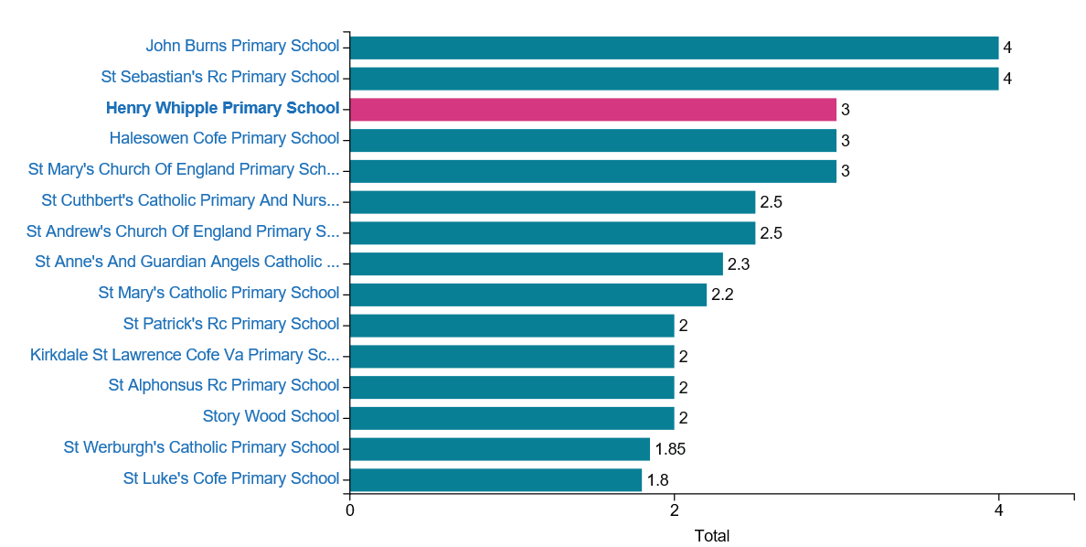
Total number of teachers (Full Time Equivalent)

This is the full-time equivalent of all classroom and leadership teachers

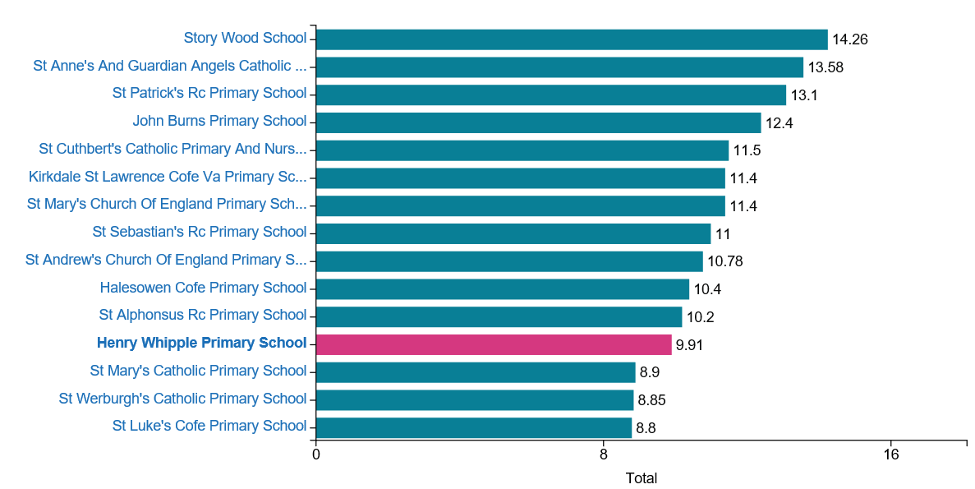

Staff percentage of Total Expenditure (£1.32m)

Based on total staff expenditure of £937.6K

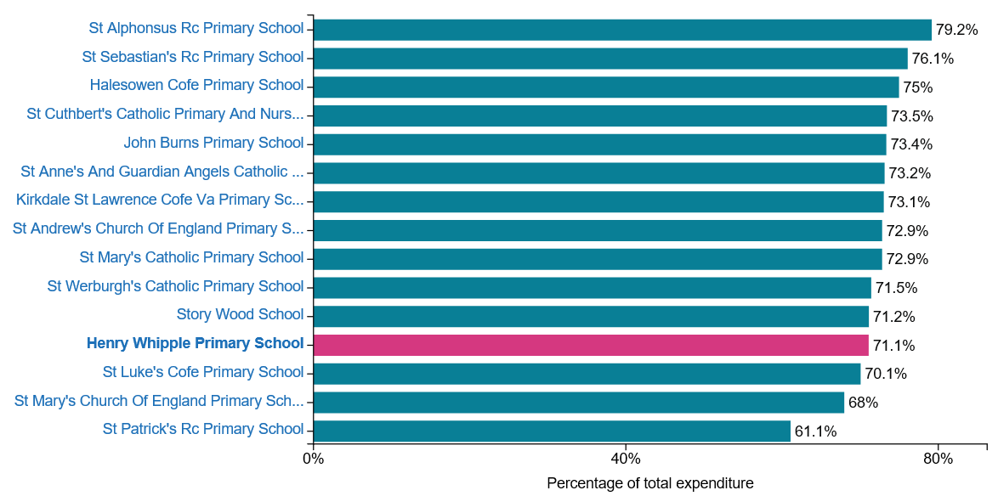

Total staff costs – Total Expenditure – 5 years

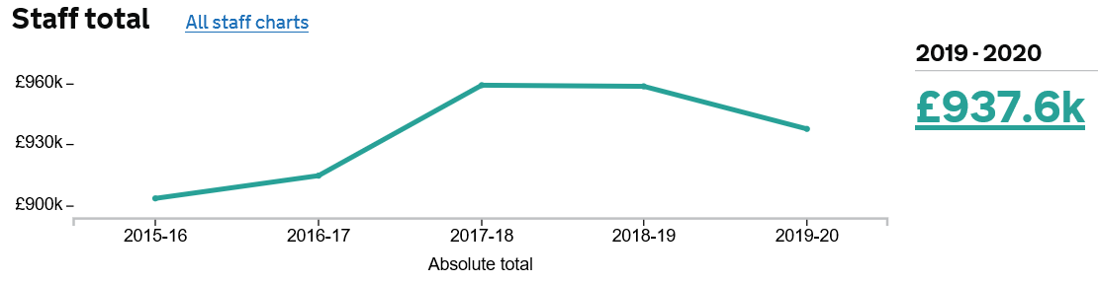

The year on year diagram above and following shows the last 5 years, a further breakdown by different staff groups follows on the next page.

Teaching staff percentage of total expenditure (£1.32m)

Based on Teaching Staff total costs of £507.9K

It includes
- costs for teachers employed directly by the school, including supernumerary/peripatetic teachers on short-term contracts
- gross pay, including allowances, maternity pay and the employer's contributions to national insurance and teachers’ pensions
- teaching and learning responsibilities (TLR)

It excludes:
- any teachers not employed directly by the school, eg agency staff

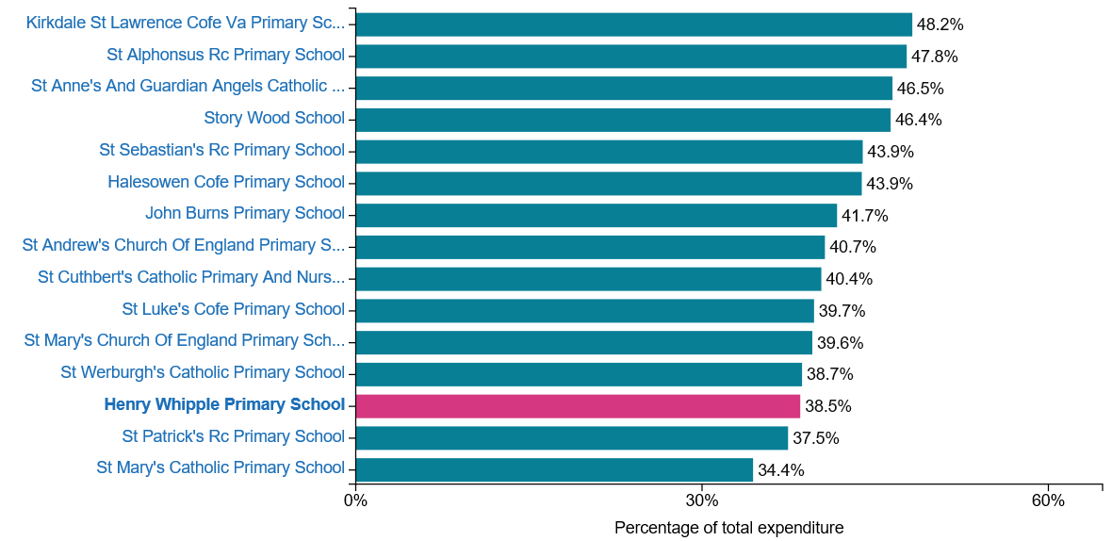

Teaching staff costs – Total Expenditure – 5 years
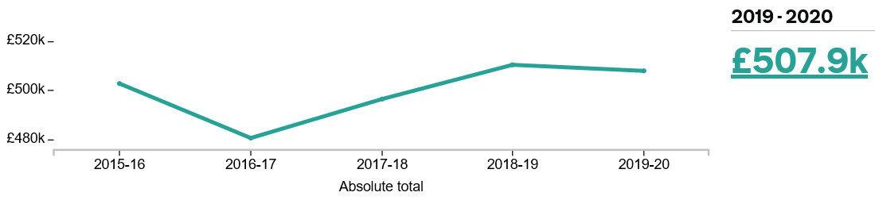

Supply Staff percentage of total expenditure (£1.32m)

Based on Supply Staffing costs of £49K

Agency Supply teachers - £34.3K
Teacher insurance - £14.5K
Supply hours by staff - £0.2K

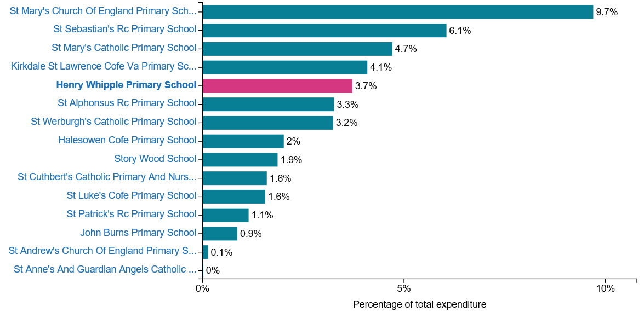
Supply staffing costs – Total Expenditure – 5 years
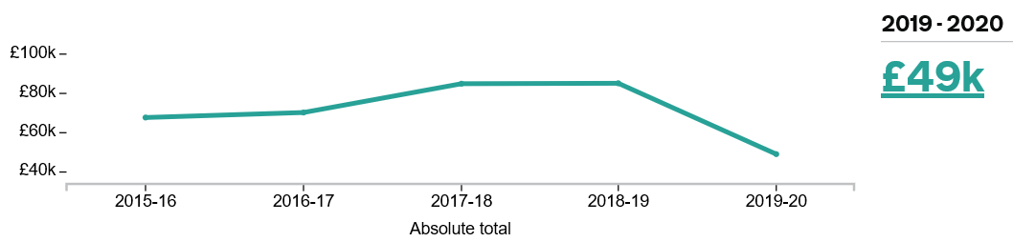

Education Support Staff percentage of total expenditure (1.32m)

Based on Education Support Staff total costs of £268.1K

This covers expenditure on the salaries of permanent support staff employed directly by the school. It takes account of allowances, maternity pay and the employer's contributions to national insurance and superannuation.

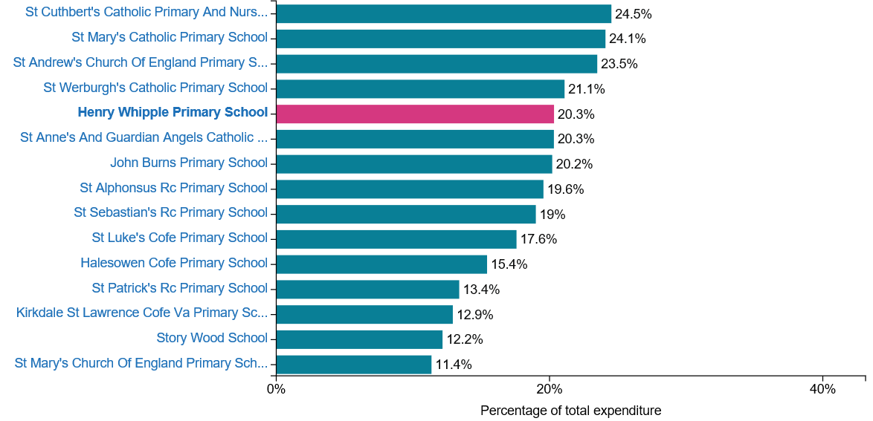

Education support staff costs – Total Expenditure – 5 years
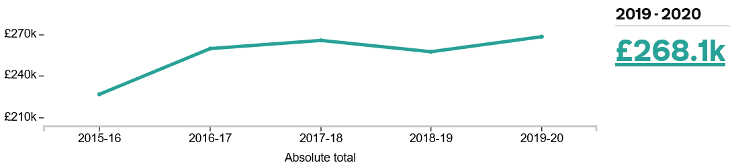

Administrative and clerical staff percentage of total expenditure (£1.32m)

Based on Administrative and clerical staff costs of £85.2K

This covers expenditure on salaries and wages of administrative and clerical staff employed directly by the school. It consists of gross pay, including allowances, maternity pay and the employer's contributions to national insurance and superannuation.

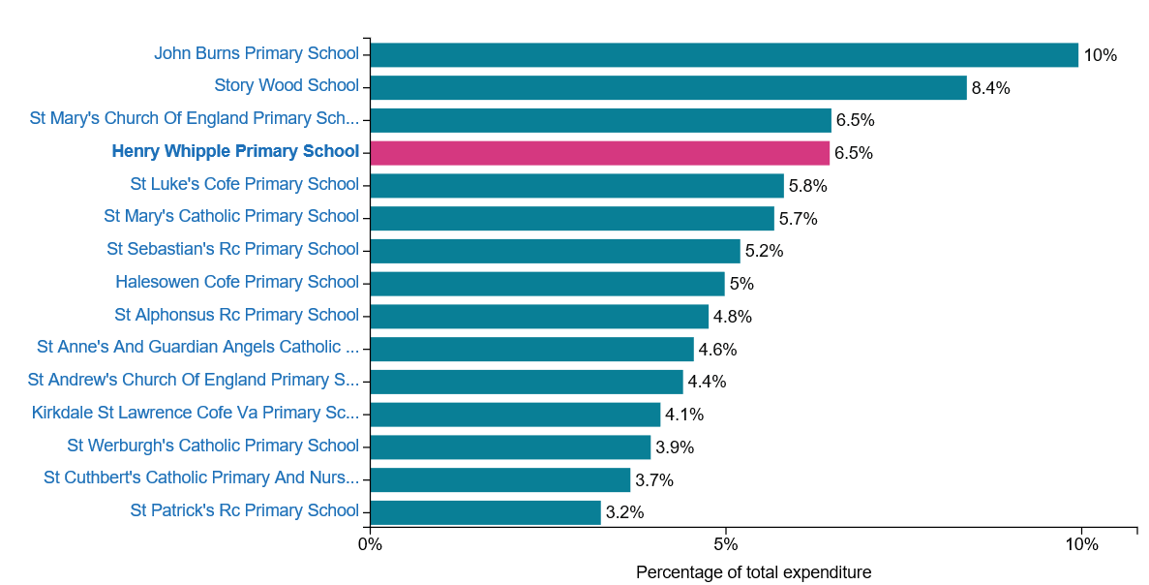

Administrative and clerical staff costs – Total Expenditure – 5 years
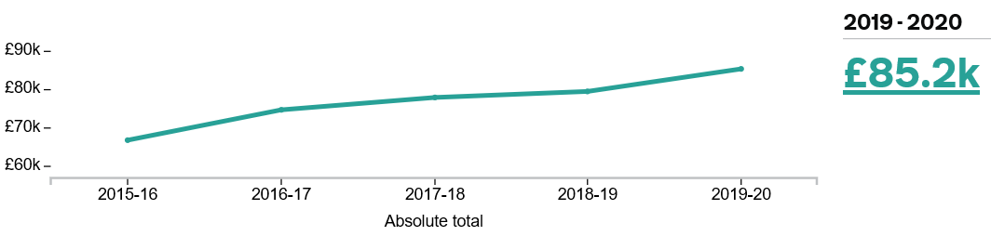

Premises costs percentage of total expenditure (£1.32m)

Based on Premises costs of £64.9K

This consists of :-

- Premises staff £2.9k
- Cleaning and caretaking £47.7k
- Maintenance and Improvement £14.2k

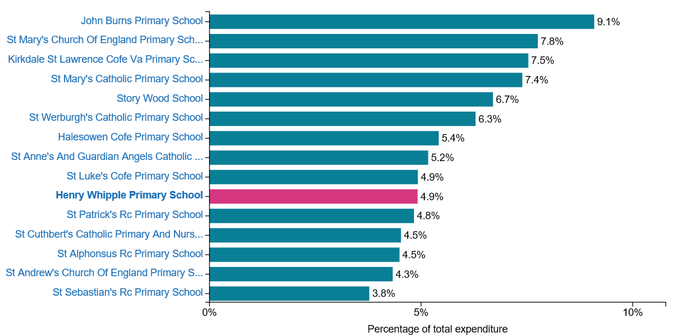

Premises costs – Total Expenditure – 5 years
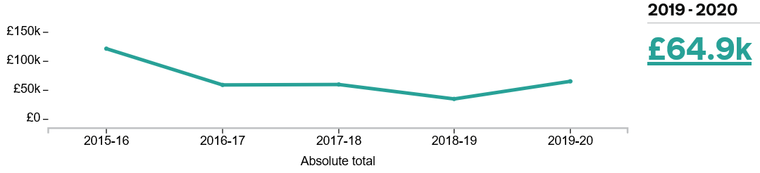

Premises staff costs – Total Expenditure – 5 years
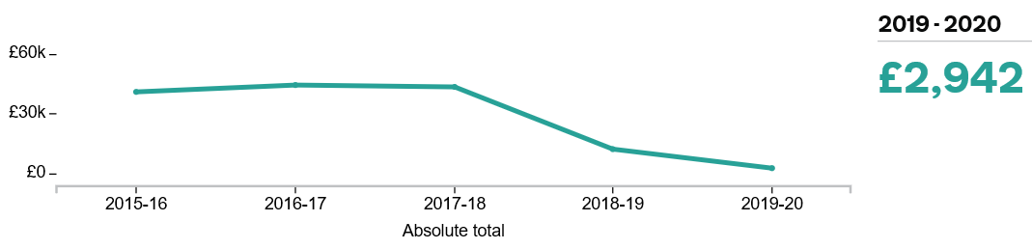

Other Staff costs percentage of total expenditure (£1.32m)

Based on Other Staff total costs of £27.4K

- Other staff costs £9.5K (Middays, Breakfast Club)
- Staff development and training £14K
- Indirect expenses £3.9K

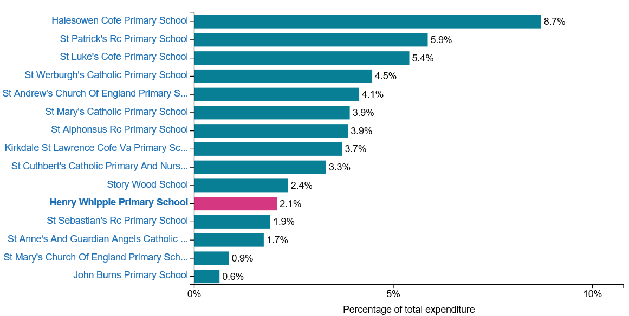

Other staff costs – Total Expenditure – 5 years
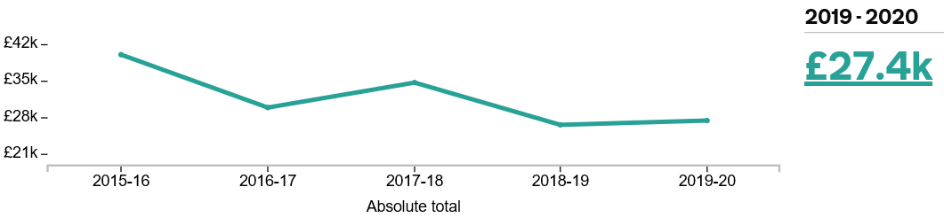

Administrative supplies cost per pupil (Total cost £26.1k)
This includes:
•administrative stationery & printing
•administrative reprographics
•postage
•bank charges
•telephone charges (not dedicated internet lines)
•medical and domestic supplies
•purchase, hire or maintenance contracts of ICT or other equipment not to be used for teaching
•purchase, hire, lease and maintenance of furniture and equipment not used for teaching
•subscriptions, publications, periodicals and copyright fees not related to the curriculum
•school publications eg parents' report and school brochure
•any governors’ expenses
•marketing costs for school prospectuses

The following chart is broken down to a per pupil basis
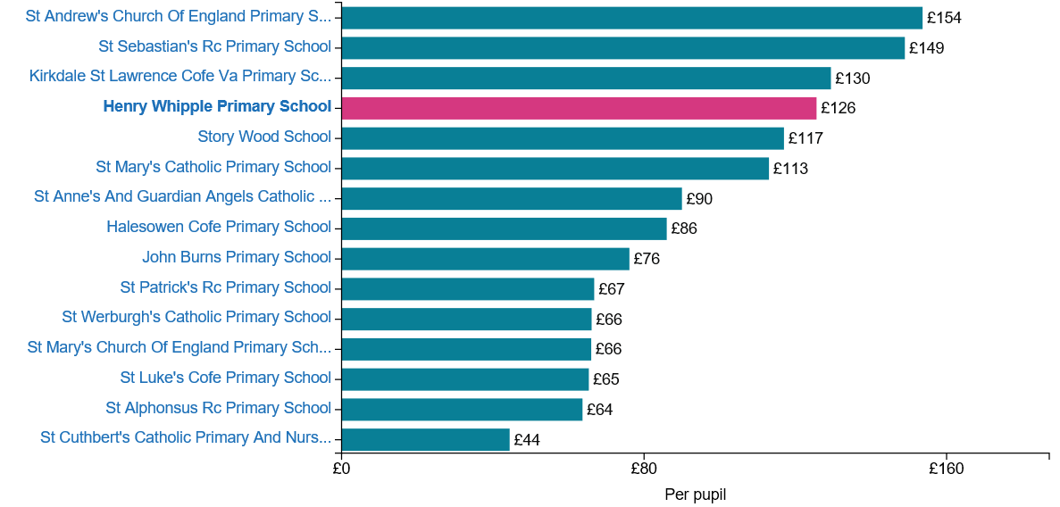

Administrative Supplies costs – Total Expenditure – 5 years

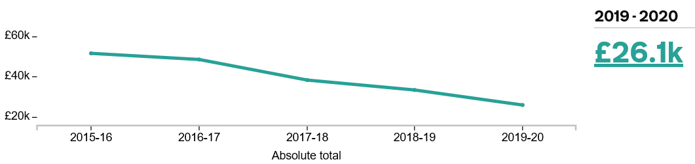

Energy Costs per pupil (Total cost £24.6k)
This includes:
- all costs related to fuel and energy, including fuel oil, solid fuel, electricity and gas
- repayment of SALIX loans (ie repayment for funding for energy efficiency projects)
It excludes:
- costs arising from repairs or maintenance to energy supplies

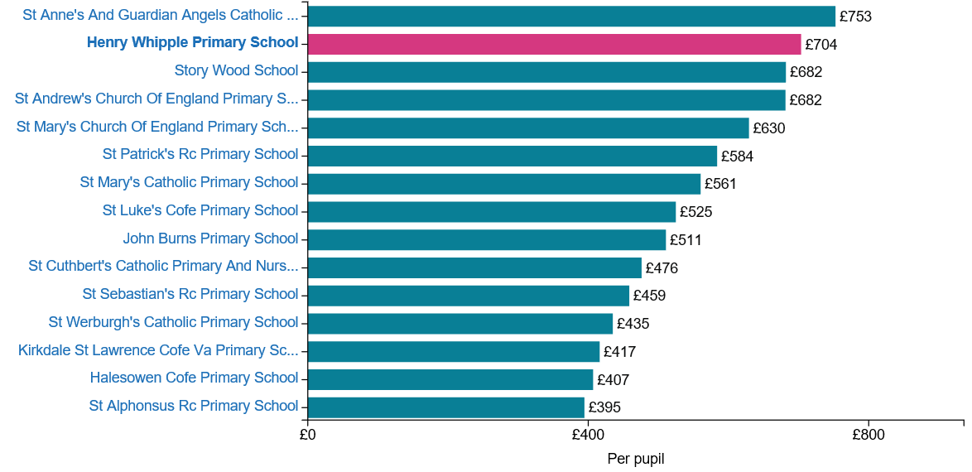

Energy costs – Total Expenditure – 5 years


