Dear Parents/Carers,
Happy new year to everyone. I hope you had a restful time with your family over the break. We are looking forward to starting the new year with another term full of new exciting learning. Our learning away this half term will be to Wollaton Hall to learn more about the Anglo Saxons. We will also look forward to learning more about keeping safe online for Safer Internet Day on Tuesday 10th February.

Class 4
Spring Term 1 Newsletter

Science: We will be revisiting our learning:
What is sound? Why are vibrations important?

Our new learning:
Investigate how sounds are made when something is vibrating and these vibrations travel to the ear.
To learn the parts of the ear and their functions.
Explore the relationship between volume and the strength of the vibrations that produced it.
Vocabulary: pitch, volume, louder, fainter, distance, source, insulator, sound wave, electrical signal

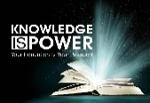
Attendance – 97% is our MINIMUM expectation
It is vital children attend on time as our learning starts 8.35am as the gates open. We always learn our spellings at the start of the day. Children must be on time so they don’t miss this learning.

Reading:
We cannot emphasise enough
the importance of reading to and with your child every day. Home learning expectations are ‘Read Every School Day’.
Please support with reading to and with your child and write in their reading diary.
Fluency Targets- By the end of Year 4
children should be reading 130 words
per minute.

Our new class reader is:
Toad Rage by Morris Gleitzman
-Limpy sets out on a perilous journey to try to persuade humans that cane toads are loveable, friendly creatures….


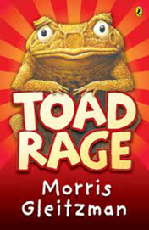
Mathematics Learning: Multiplication and Division
We will be starting the term with multiplying and dividing by 10 and 100. We will use concrete and pictorial representations to help children visualise the multiplication and division calculations.
X tables- We will continue to focus on our times tables this half term. It is expected for year 4 to be able to recall all times tables up to 12. You can use this website to help generate times tables quizzes at home:
http://www.timestables.me.uk/printable-pdf-quiz-generator.htm

Key dates:
Thursday 22th January 2026
Learning Away- Wollaton Hall

Wednesday 11th February 2026 9.00-9.30am
Learning Together- Keeping Safe Online

History – The Anglo Saxons

We will be learning about where the
Anglo Saxons came from now how the Anglo Saxons created seven kingdoms in Britain. We will also learn how Anglo Saxons named places and how this links to today. We will learn why the Anglo Saxons settled in Britain and how Anglo Saxons lived in Britain
Know that the Anglo Saxons were pagans and then converted to Christianity (cause and consequence)
Know that when important people died, they were buried with their possessions
Key vocabulary-; Settlers, churl, hierachy, thane, thrall, archeology, evacuation, monestry.

PE Days: MONDAY AND THURSDAY
Your child must come in their PE kit on these days.
PE kit is:
Plain red t-shirt
NO BRANDED LOGOS

No jewellery can be worn due to
health and safety. Please remove
earrings or ensure your child can.
If not, we have medical tape to cover them.

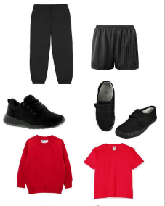
Writing:
This half term in writing we will be learning to:
- Write newspaper articles
- Poetry

